WEEK-3
AIM: A) Design a responsive UI that adapts to different screen sizes.

DESCRIPTION:
Responsive UI in Flutter refers to creating user interfaces that automatically adjust their layout and appearance based on the screen size of the device. This ensures a smooth and consistent user experience across smartphones, tablets, and desktops. Flutter offers tools like LayoutBuilder, MediaQuery, and flexible widgets such as Row, Column, and Expanded to help developers design adaptive layouts. These tools detect screen dimensions and allow the UI elements to scale, rearrange, or resize accordingly.

PROGRAM:
import 'package:flutter/material.dart'; void main()
{
runApp( MaterialApp( home : Scaffold(
appBar : AppBar(title: const Text('Simple Responsive UI')), body : LayoutBuilder(
builder: (contexdt, constraints){
final width = constraints.maxWidth; String text = ' Mobile View';
IconData icon = Icons.phone_android; double fontSize = 24;

if ( 600 <= width && width < 1200){ text = 'Tablet View';
icon = Icons.tablet; fontSize = 28;
}
else if(width >= 1200){ text = 'Desktop View';
icon = Icons.desktop_windows; fontSize = 32;
}
return Center( child: Column(
mainAxisSize: MainAxisSize.min, children:[
Icon(icon, size: 80),
const SizedBox(height: 20),
Text(text, style: TextStyle(fontSize : fontSize)),


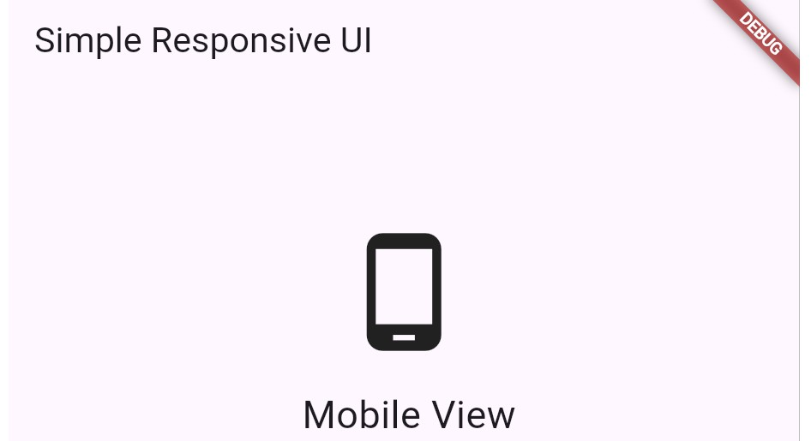
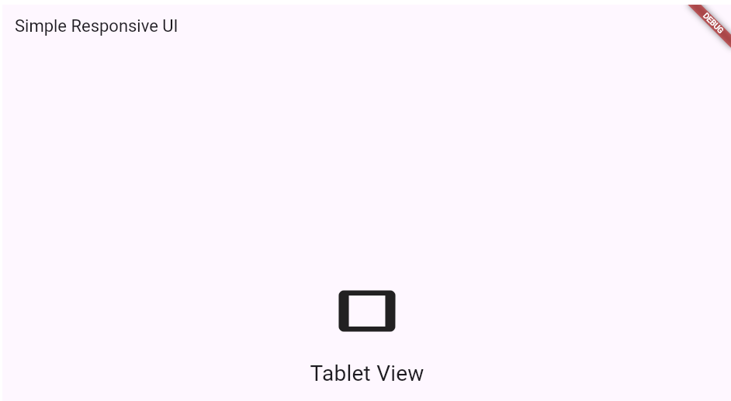
]
)
);
}
)
)
)
);
}

OUTPUT:

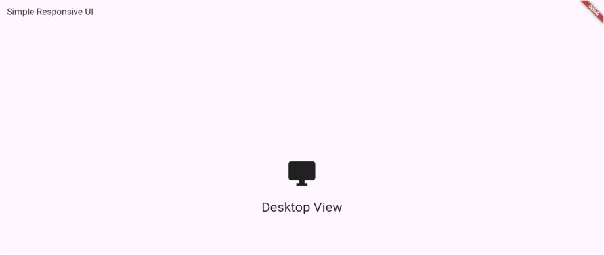


AIM: B) Implement media queries and breakpoints for responsiveness. DESCRIPTION: Media queries and breakpoints are essential tools in Flutter for building responsive user interfaces. Using MediaQuery, developers can access information about the device’s screen size, orientation, and pixel density. Breakpoints are specific width thresholds used to define different layouts for mobile, tablet, and desktop views. By checking these breakpoints in the code, Flutter apps can dynamically adjust UI elements—such as font size, widget visibility, or layout structure—to provide an optimal experience on various screen sizes. PROGRAM:
import 'package:flutter/material.dart'; void main()
{
runApp( MaterialApp( home : Scaffold(
appBar : AppBar(title: const Text('Responsive with Media Query')), body : Builder(
builder: (context){
final width = MediaQuery.of(context).size.width; String text = 'Small Screen';
IconData icon = Icons.phone_android; double fontSize = 24;

if ( 600 <= width && width < 1200){ text = 'Medium Screen (Tablet)'; icon = Icons.tablet;
fontSize = 35;
}
else if(width >= 1200){
text = 'Large Screnn (Desktop)'; icon = Icons.desktop_windows; fontSize = 45;
}
return Center( child: Column(
mainAxisSize: MainAxisSize.min, children:[
Icon(icon, size: 80),
const SizedBox(height: 20),
Text(text, style: TextStyle(fontSize : fontSize)), const SizedBox(height: 10),
Text('Screen width: ${width.toStringAsFixed(0)} px')
]
)


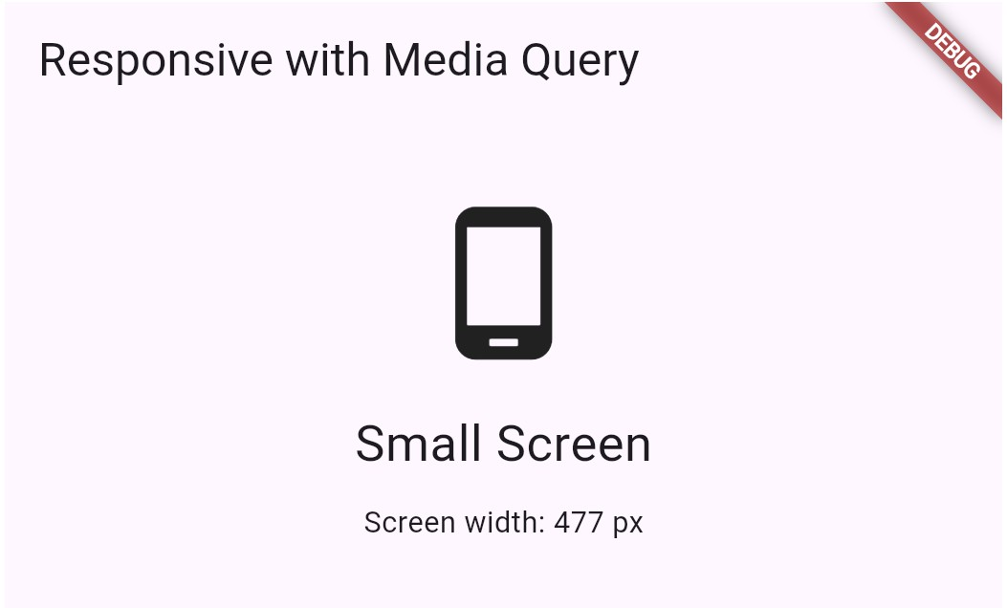
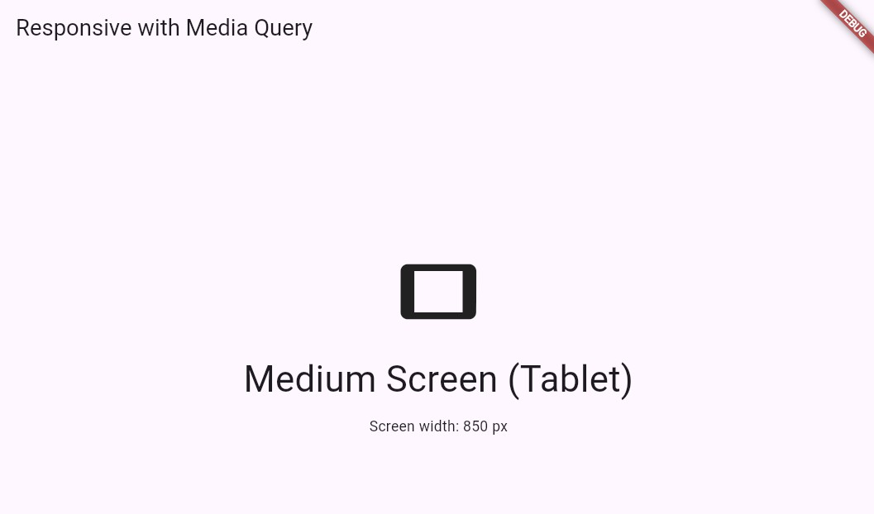
);
}
)
)
)
);
}
OUTPUT:

